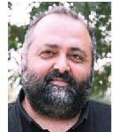

**Educational Background**

B. Sc. İstanbul Technical University

M. Sc. Technical University of Denmark

Ph. D. Technical University of Denmark

**Research Interests**

Wind Energy Meteorology

Remote Sensing

Scientific Computing

**Contact**

[ferhatbingol@iyte.edu.tr](mailto:ferhatbingol@iyte.edu.tr)

+90 232 750 6723

Engineering Faculty - B, Office: Z-20